Hello Maria,

I have completed the update of the information for Thomas High School. All 9th graders scores for math and reading have been changed to “NaN”.

After running again the coding, here is how the information has been affected.

1. How is the district summary affected?





For the district summary the “Average Math Score”, “Average Reading Score”, “Math Passing percentage” and “Reading Passing percentage” all decreased after the update, hence the “Overall Passing percentage” went from a 65% to a 64%.

1. How is the school summary affected?







As seen in the image above the overall passing per school, for Thomas High School, went from a 91% to a 65%. The drop is really bit as we have updated all the scores from a complete grade, hence this scores are not being considered for the comparison. This means that while we had the scores from 9th grade the school had an Overall passing percentage of 91% of the students, without the scores the percentage has lowered to 65% of students passing.

1. How does replacing the ninth graders’ math and reading scores affect Thomas High School’s performance, relative to the other schools?

After we updated the scores for Thomas High School’s 9th graders, the school dropped from an Overall Passing percentage of 91%, placing the school as the second school with best Overall Passing percentage, to a 65%, placing the school in an eighth place In comparison to the rest of the schools in the district.

Second place with **% Overall Passing** 91%

Eighth place with **% Overall Passing** 65%

1. How does replacing the ninth-grade scores affect the following?
2. Math and Reading Scores by Grade

**Math**







**Reading**







These images just show how the 9th graders scores were updated to NaN. The rest of the grades are not affected by this change.

1. Scores by School Spending







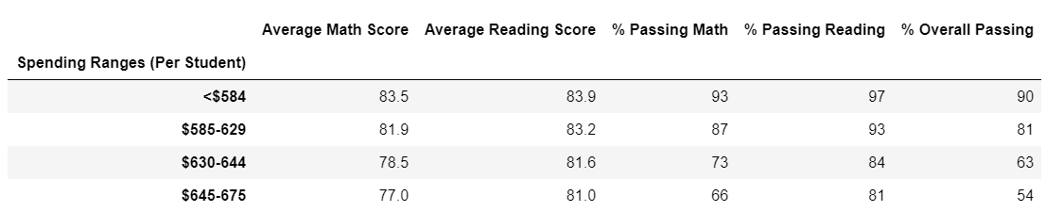

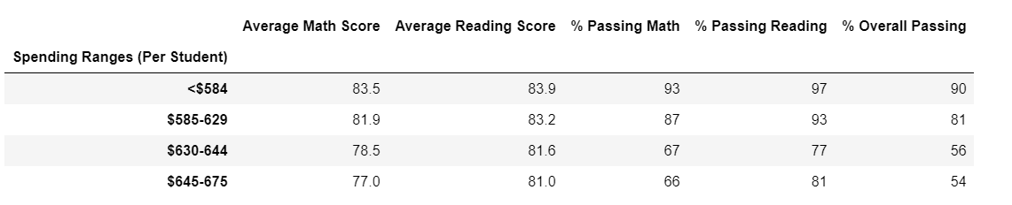

Thomas high school is placed in the “$630-644” range. This is the 2nd highest range. On the first analysis, this spending was justified because of the 91% of passing students in Thomas High School. With the new data and Thomas High School dropping to a 65%, being in this spending range seems unjustified. This change is also affecting the spending summary of the complete district. Thomas High School range dropped from an Overall Passing percentage of 63% to a 56%.

1. Scores by School Size







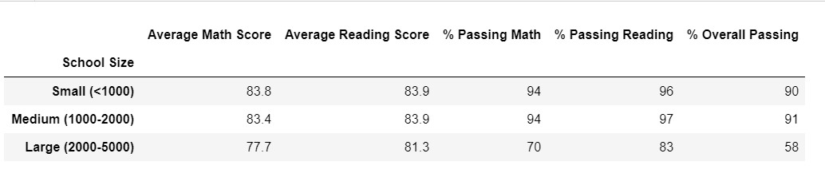

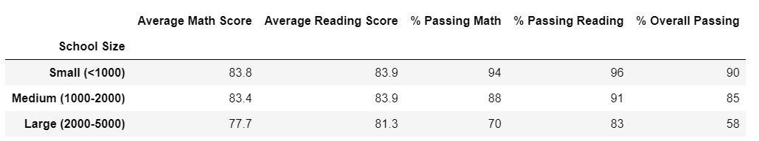

Thomas High school is a medium size school. It is placed on the size range of 1000-2000 students. As it is a medium size school the change of the 9th graders scores affect the overall passing percentage of the entire district. Although the change is not big, it brings the percentage from a 91% to an 85% of Overall Passing percentage for Medium size schools.

1. Scores by School Type

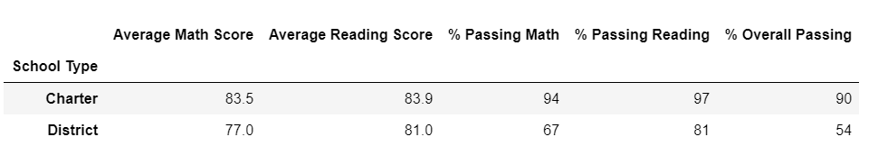

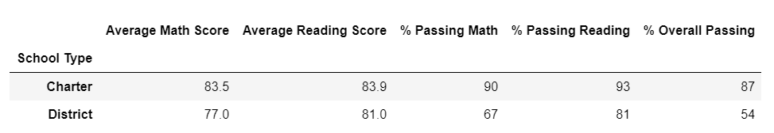

Finally, the scores update affected the school type “Charter” schools. The school type “District” was not affected at all as Thomas High School is not a District type. As shown in the information above, all scores for the “Charter” school type passing percentages were affected and dropped.

After changing the information for Thomas High School’s 9th graders, the most affected is the school itself. Its indexes dropped drastically and the school became a high scores school to low scores school. Even though the overall district saw a drop as well in its indexes, the size of the 9th graders from a medium size school impact is not really big.